Capstone Project Assessment

Project 1 – Threat Model the AI Identity System

1. Threat Modelling – Identity types in the SecureNova AI Platform

1.1 Human user (customer)
The actual end-user or customer interacting with the application. This is a highly secure, standard flow for public and native applications to securely authenticate users without exposing credentials.
Authentication Mechanism | Auth0 Universal Login utilizing OIDC Auth Code + PKCE, alongside TOTP MFA (Time-based One-Time Password Multi-Factor Authentication).
Privilege  Level | read:ai-data (own data only). The user can only view or read AI-generated data or responses that belong strictly to their own account context.

1.2 Human admin / support lead
Internal staff members who manage the system or provide customer support.
Authentication Mechanism | The same as the user (Auth0 + MFA), but strictly enforced through an enterprise connection (SSO).
Privilege  Level | read:ai-data, write:admin. They have elevated privileges allowing them to read general AI data and execute administrative write/configuration actions.

1.3 AI agent (LLM agent)
The central core AI or Large Language Model orchestrator executing tasks.
Authentication Mechanism | Acts on behalf of user via a user's access token (OBO - On-Behalf-Of flow) combined with an agent_id claim using Ed25519-signed inter-agent messages. This ensures that the agent's actions are cryptographically signed and directly tied to the authorizing user's session.
Privilege  Level | Inherits user scope, never more. The AI agent is strictly sandboxed; it cannot perform any action or access any data that the initiating human user does not already have permission to access.

1.4 OAuth M2M client (agent backend)
The backend service infrastructure supporting the AI agent, communicating machine-to-machine (M2M).
Authentication Mechanism | Client Credentials utilizing a client_secret or private_key_jwt with a short 60-300s TTL (Time-To-Live). This is standard for secure server-to-server communication where tokens expire rapidly to reduce exposure of windows.
Privilege  Level | read:ai-data. The backend service has programmatic read access to the broader pool of AI system data to serve its functions.

1.5 LLM API key (model provider)
The credential used to authenticate requests sent to the upstream foundational model provider (e.g., OpenAI, Anthropic).
Authentication Mechanism | Static bearer key securely injected and retrieved via a secrets manager.
Privilege  Level | Inference only, billing exposure. This key is strictly restricted to running model inference (generating text/data) but carries a risk profile related to financial/billing consumption if abused

1.6 RAG pipeline service identity
The automated background service responsible for Retrieval-Augmented Generation (RAG) processes.
Authentication Mechanism | M2M token providing read-only access to the vector store database.
Privilege  Level | read:kb. It holds restricted permission to query and read data from the system's Knowledge Base (kb) to contextualize LLM prompts.

1.7 MCP server identity
The Model Context Protocol (MCP) server identity, which manages tools or integrations the AI can invoke.
Authentication Mechanism | M2M token per tool paired with a per-tool scope. Every tool integration has its own isolated, highly specific token.
Privilege  Level | Tool-specific (write:admin, read:pii-export). Depending on the specific tool's role, it can carry highly sensitive privileges like administrative writes or exporting Personally Identifiable Information (PII).

2. STRIDE Matrix – With Data Flow Diagram

2.1 STRIDE Matrix
Applying all six STRIDE categories to every identity flow) in the system.
Flow | S (Spoofing) | T (Tampering) | R (Repudiation) | I (Info disclosure) | D (Denial of service) | E (Elevation)
User -> Chat App (login) | Credential stuffing / phished session | Token tampering in transit (mitigated TLS) | User denies action; no per-user audit logs | ID token leakage in logs | Login flood | Account takeover -> admin
Chat App -> Agent (user token) | Stolen/replayed access token | Prompt tampering in request | Agent actions not tied to sub | Token echoed in LLM context | Token-heavy requests | Agent accepts self-asserted role
Agent -> LLM provider (API key) | Stolen API key used by attacker | Response manipulation | No key-level audit | Key exfil via prompt injection | Unbounded consumption / quota burn | Key shared across envs
Agent -> RAG pipeline | Fake KB source | Chunk poisoning | Unknown chunk provenance | Over-broad retrieval of other tenants' data | Vector DB exhaustion | Retrieved text treated as instructions
Agent -> MCP server | Tool-call forgery | Tool args tampered | No tool-call log | Tool returns PII | Tool call loops | Agent calls admin tool without scope
F6 Agent A -> Agent B | Orchestrator impersonation | Message altered mid-hop | Sender can deny instruction | Context leakage between agents | Message flood | Privileged action by spoofed message
F7 M2M client -> Internal API | Client secret theft | JWT algorithm confusion | Missing jti / client audit | Long-lived tokens leaked | Token-endpoint abuse | Scope creep on M2M app
F8 Auth0 -> apps (token issue) | Rogue IdP / misconfigured callback | Claim tampering (needs RS256 verify) | Auth0 log retention too short | Verbose errors | Brute-force lockouts used as DoS | Overly broad scopes/audience

2.1 Data-flow diagram
This is the complete data-flow diagram (DFD) of the system built in OWASP Threat Dragon having three layers as TB1(User Layer), TB2(Agent Layer), TB3(Internal API Layer).
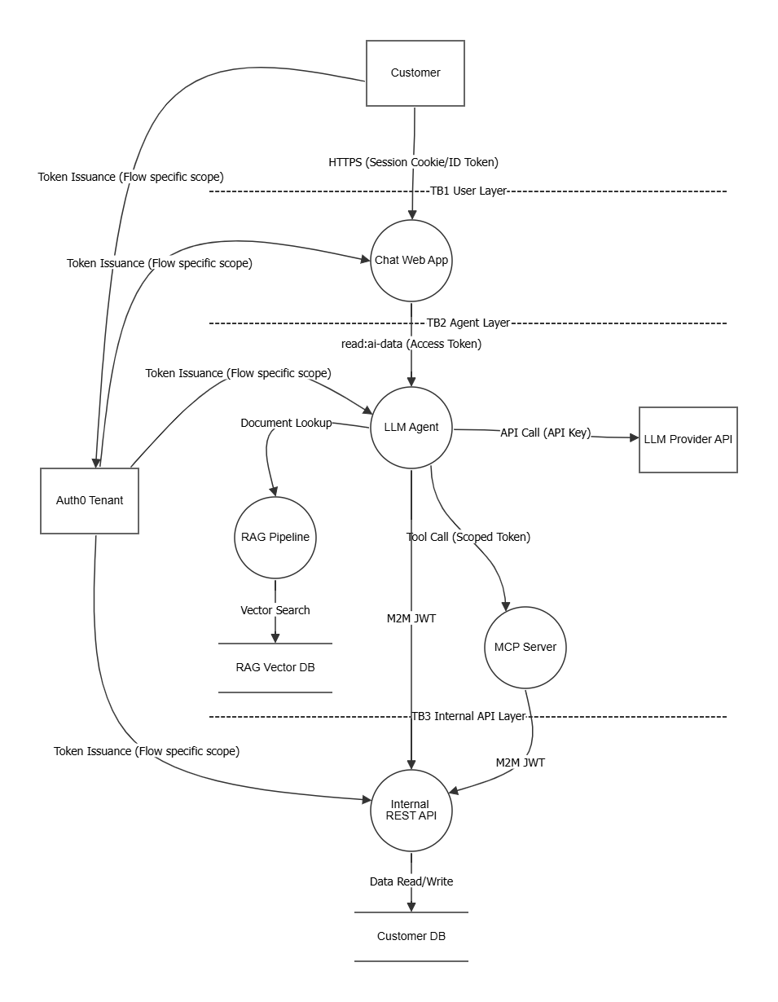
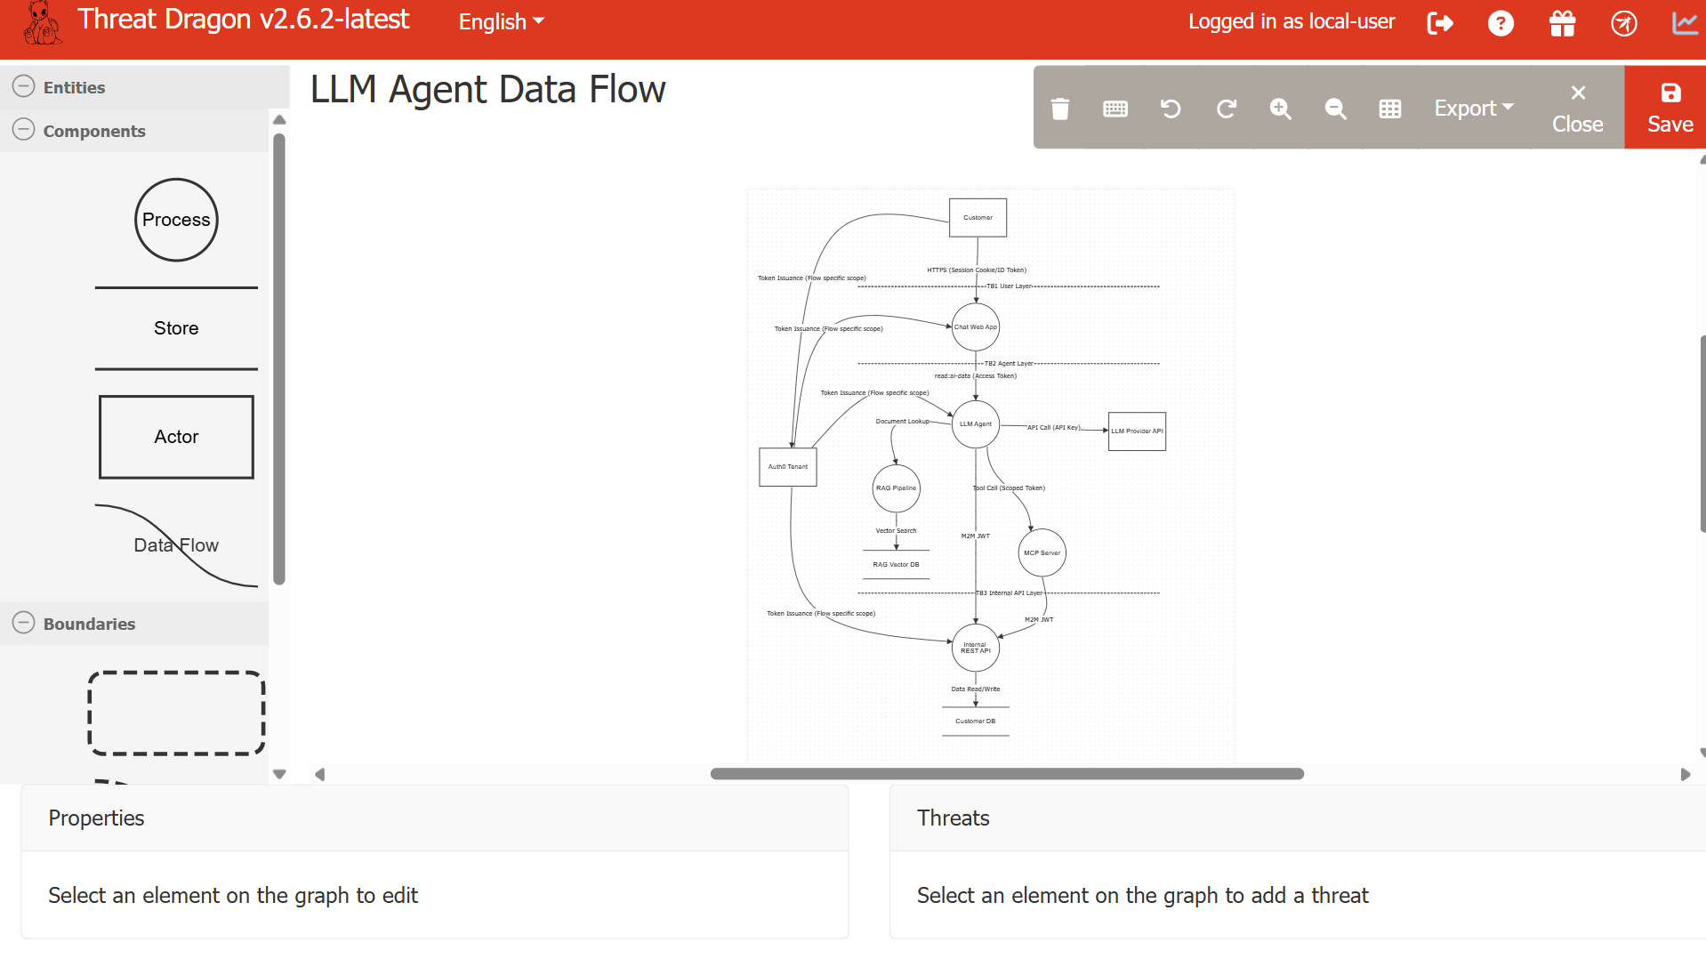
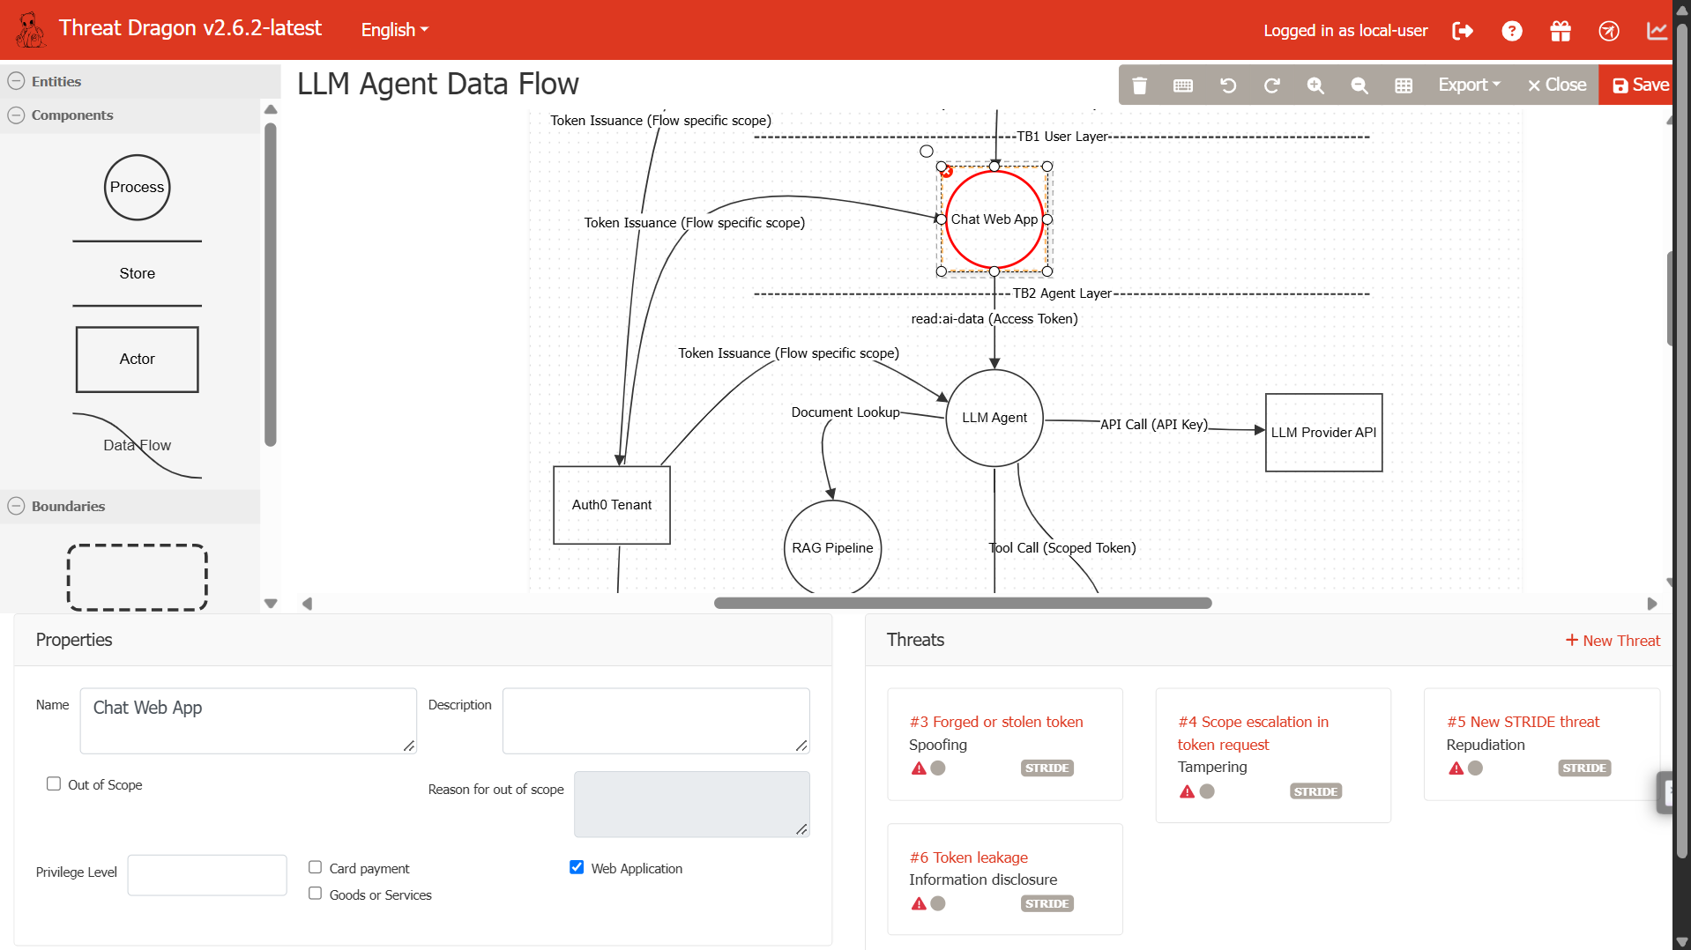This image shows some of the STRIDE Threats for identity flow shown with red color in the diagram. Auth0 Tenant → Chat Web App (Token Issuance).

3. Attack Trees and The Scores of each Threat

3.1 LLM API key exfiltration via prompt injection
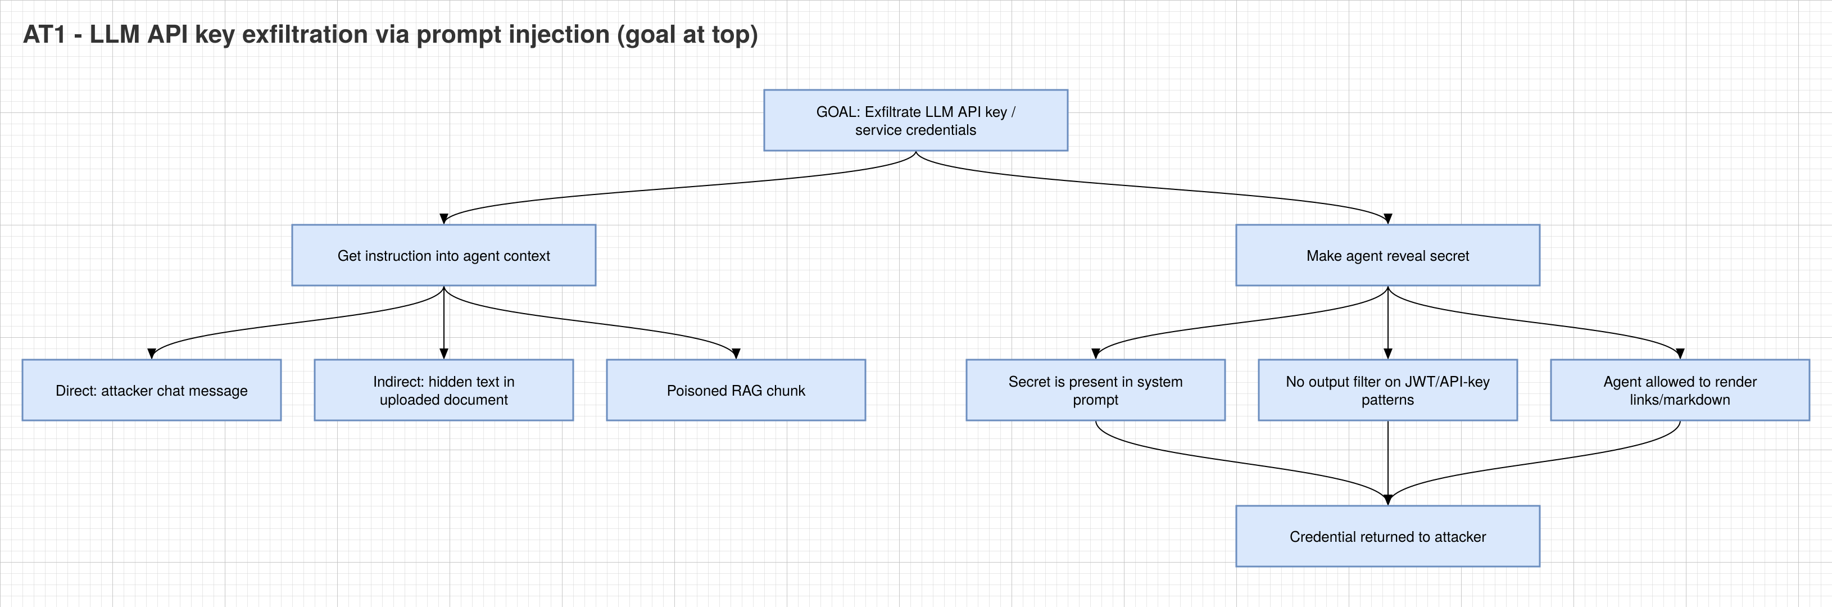Risc Score = Likelihood x Impact = 4 x 4 = 16 (High)

3.2 Agent identity spoofing to gain elevated API scope
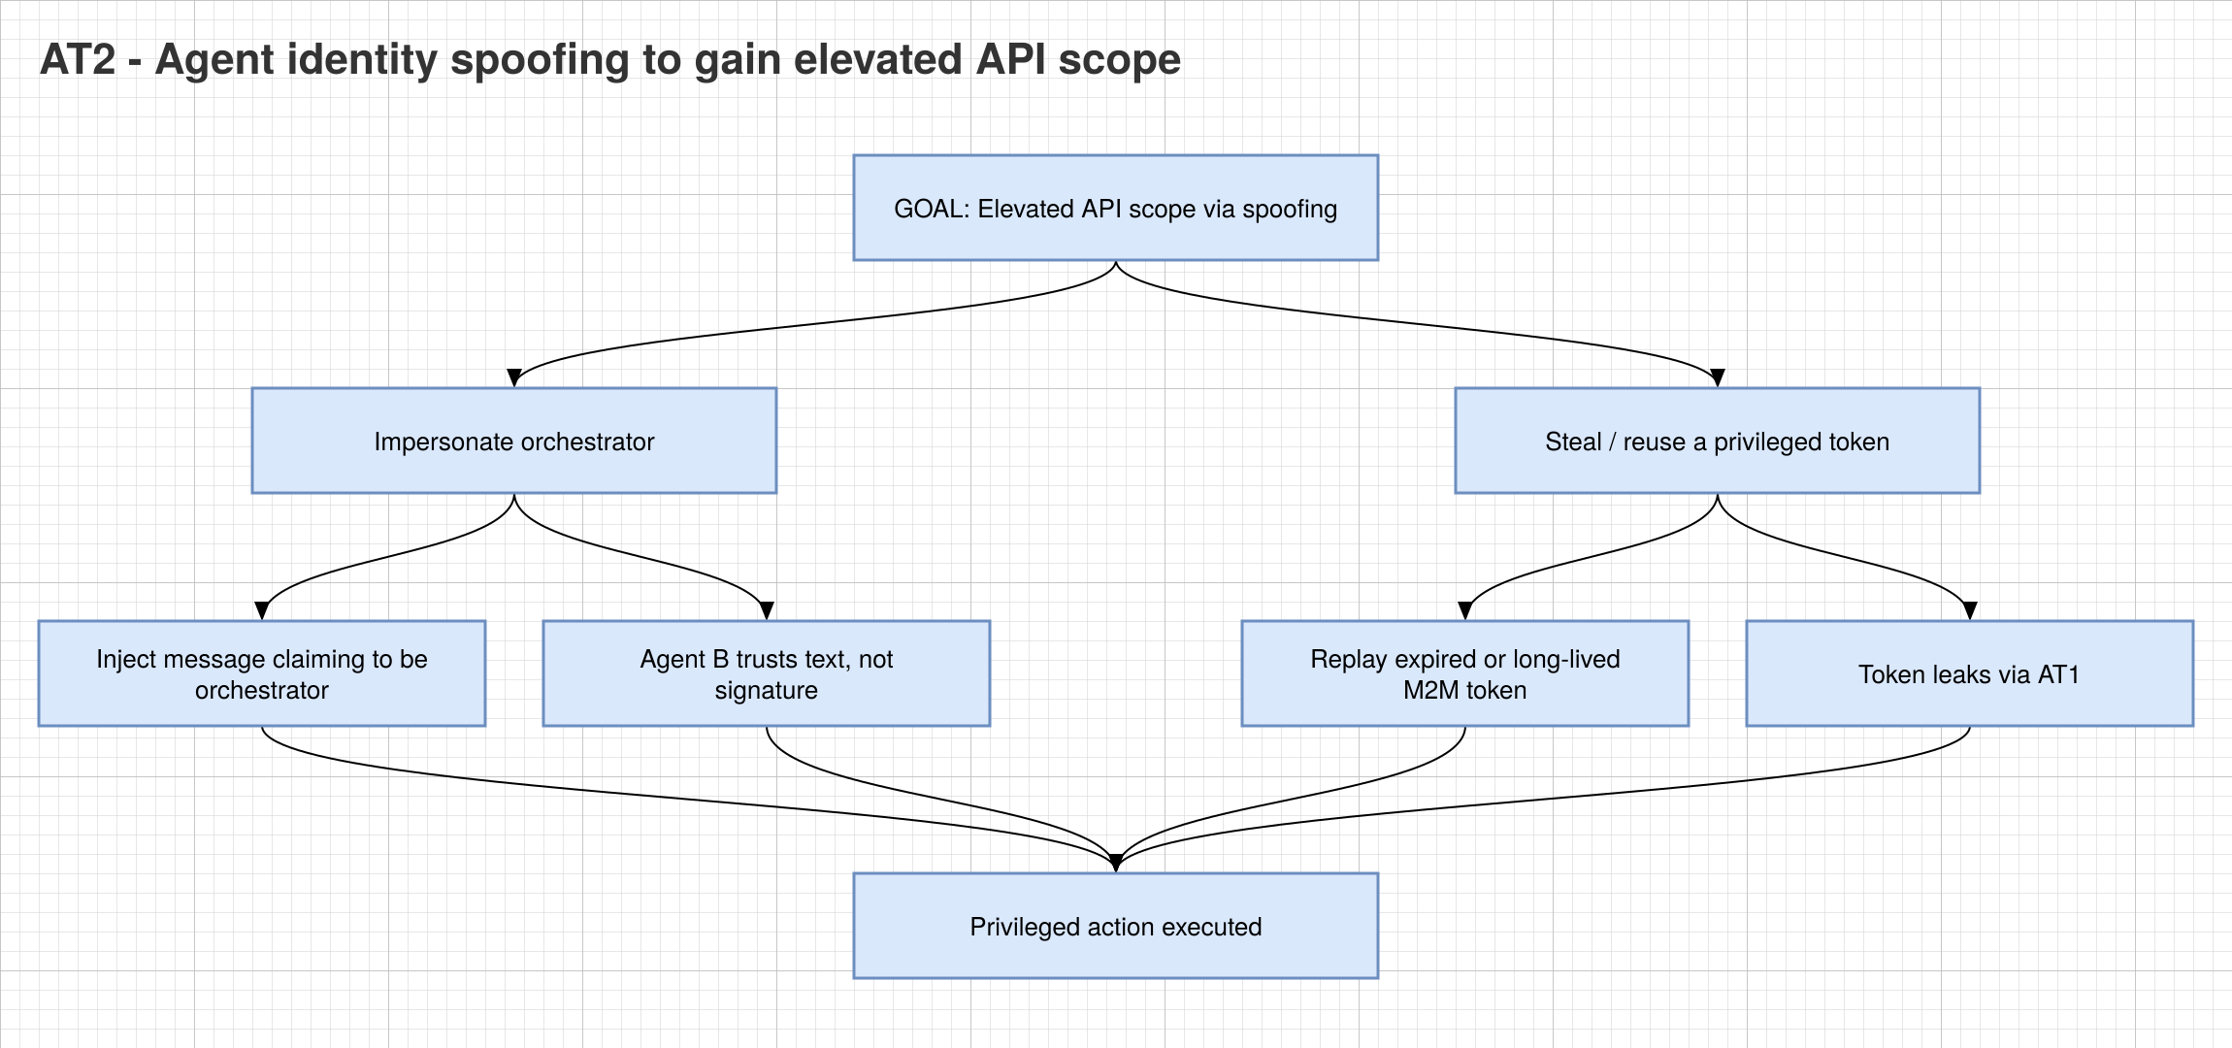Risc Score = Likelihood x Impact = 3 x 5 = 15 (High)

3.3 RAG chunk poisoning to manipulate agent behavior
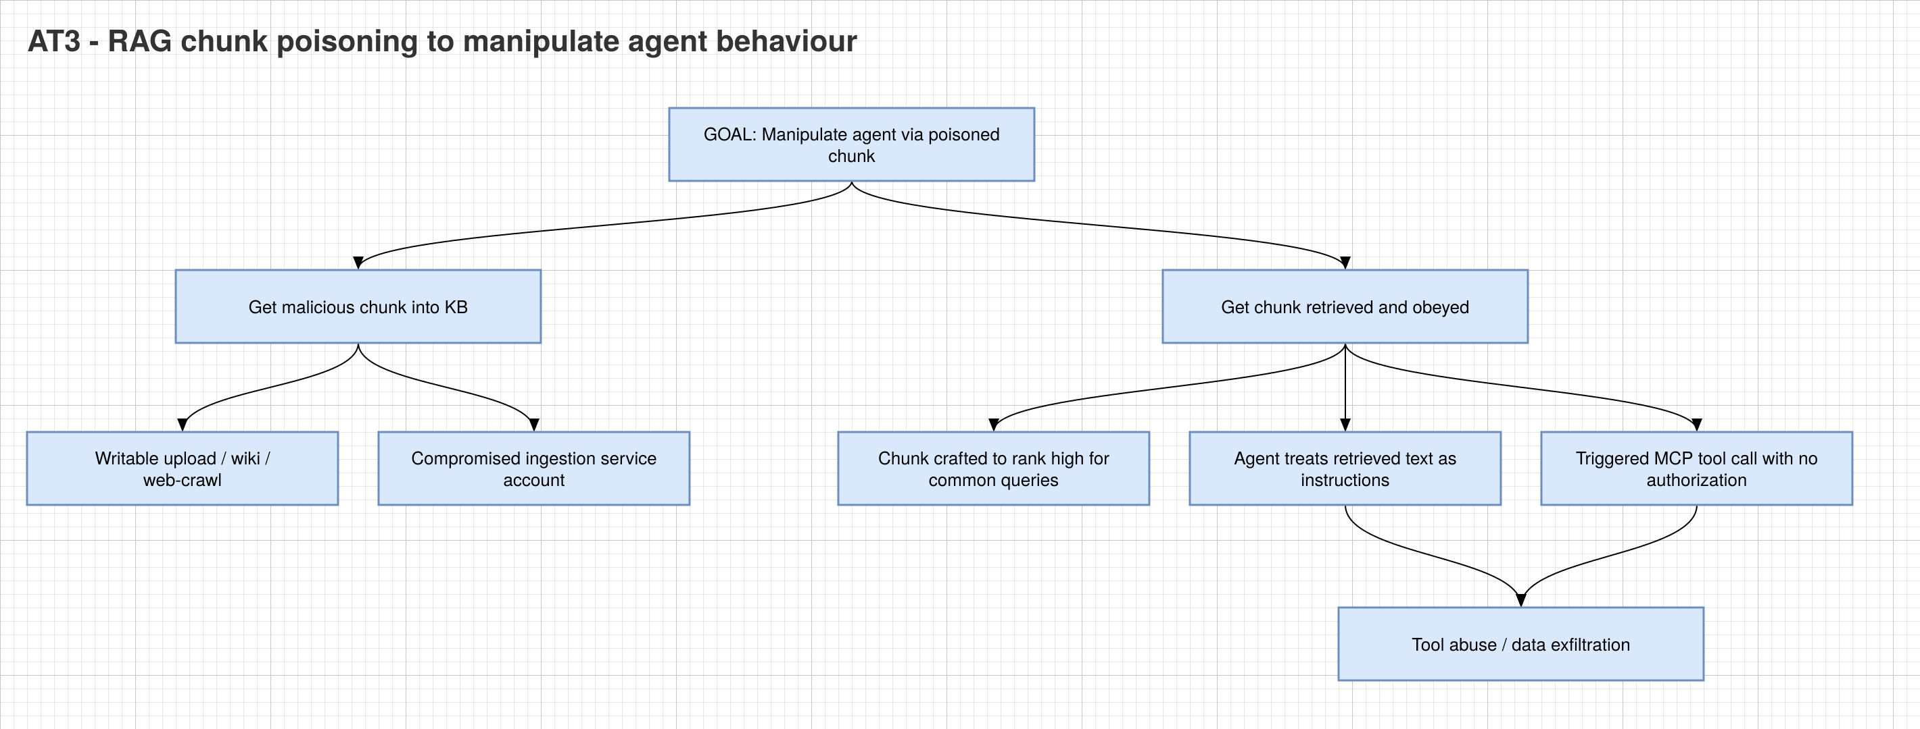Risc Score = Likelihood x Impact = 4 x 4 = 16 (High)

4. MITRE ATLAS Mapping

4.1 Mapping each Attack Tree to the Closest MITRE ATLAS Technique
Attack Tree Scenario | Closest ATLAS Technique | ATLAS ID
Key exfiltration via prompt injection | LLM Prompt Injection | AML.T0051
Agent identity  spoofing | Impersonation | AML.T0073
RAG chunk  poisoning | RAG Poisoning | AML.T0070

The above image provides the id of all the closest MITRE ATLAS Technique. And the image below shows the RAG Poisoning technique that we got on the mitre atlas organization.
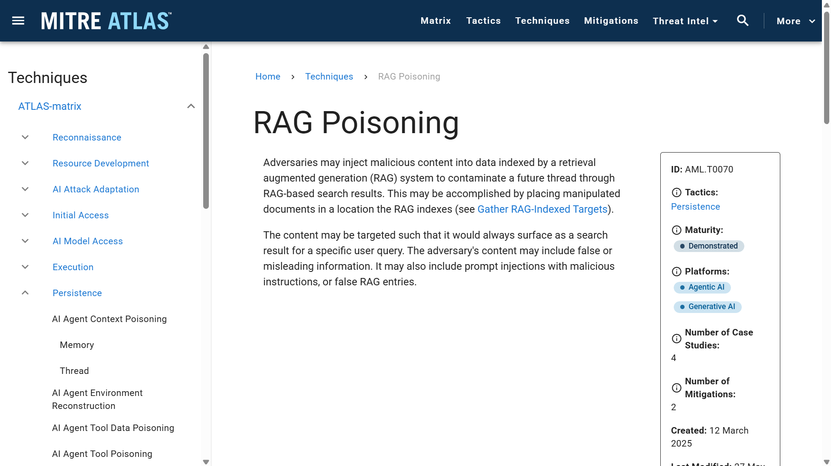

4.2 Final Risk-Ranked Register
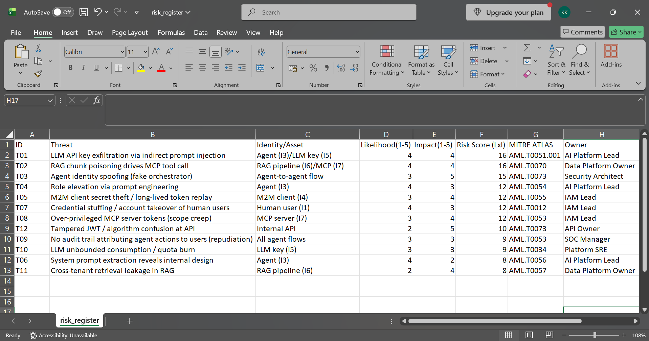

----------------------------------------- END OF PROJECT 1 ---------------------------------------------

